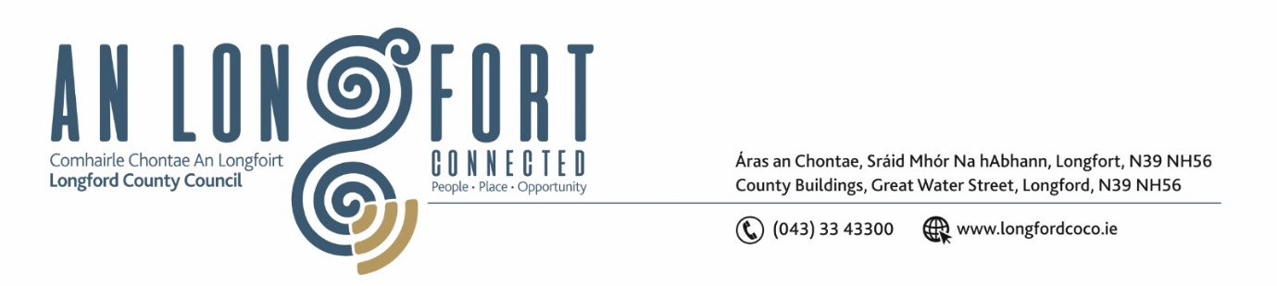

**GRANARD MUNICIPAL DISTRICT**

***Please note meeting will be held in Granard Library.***

**20 February 2024**

**To: Each Member of Granard Municipal District.**

**Dear Member,**

You are requested to attend a Meeting of Granard Municipal District to be held in Granard Library on **Tuesday 27 February 2024 at 3.00pm** to transact business, as set out on the Agenda hereunder.

**Yours sincerely**,

______________________

**Claire McNabola,**

**Meetings Administrator**

**AGENDA**

Prayer before meeting.

**1.** Confirmation of Minutes as follows:

1. Granard Municipal District Meeting held on 28 November 2023 – enclosed.

**2.** Matters arising from Minutes.

**3.** Declaration of Interest by Members.

**4.** Management Report incorporating Area Engineer’s Progress Report – enclosed

**5**. Community Grant Support Scheme 2024 – to follow

**6.** Granard MD Special Projects / Discretionary Grants 2024

**7.** Consideration and adoption of Draft Municipal District Report for inclusion in

Longford County Council 2023 Annual Report

**8.** Town Twinning Reports

**9**. Consideration of Part VIII No 116 Granard Shared Footpath and Cycleway Co Longford.

**10.** Notices of Motions, submitted by Councillors, as listed hereunder:

**Councillor Paraic Brady**

1. I call on Longford County Council to review the speed limit in Ennybegs, to move the 50kmph back towards the School from Hagan’s Lane

**Councillor Colin Dalton**

1. I call at Longford County Council to include the Clonbroney, Edgeworthtown Road on the winter Gritting programme 2024 .
2. I call on Longford County Council to review the traffic calming Measures in Ballinalee village at St. John’s Estate, and also to review traffic calming Measures at Ballinalee National School.